Isabelle Henderson Memorial Invitational – September 18-21, 2015
Payton Marr | Senior Bronze Women | 4
Alexandra Klunder | Senior Bronze Women | 11
Mackenzie Campbell | STAR5 Girls overer 13 | 4
Jodie Van Eck | STAR5 Girls under 13 | 1
Negeen Ahmadi | STAR5 Girls under 13 | 3
2015 Skate Canada Western Ontario Sectional Championships – November 6-8, 2015
Payton Marr | Pre-Juvenile Women under 13 | 2
John McKay Memorial Invitational – November 28-29, 2015
Kira Miller | Junior Silver Women | 6
Thomas Turner | Senior Silver Men | 1
Payton Marr | Senior Bronze Women | 2
Alexandra Klunder | Senior Bronze Women | 5
Kalysta Fletcher | Senior Bronze Women | 7
Mackenzie Campbell | STAR5 Girls over 13 | 2
Ava Stechey | STAR5 Girls over 13 | 5
Jodie Van Eck | STAR5 Girls under 13 | 2
Negeen Ahmadi | STAR5 Girls under 13 | 5
Alexandra Klunder | Bronze Women Interpretive | 8
Charles Dover Memorial Invitational – January 8-10, 2016
Alexandra Klunder | Women's Bronze Triathlon | 3
Thomas Turner | Junior Silver Men | 2
Payton Marr | Senior Bronze Women | 3
Kalysta Fletcher | Senior Bronze Women | 10
Ava Stechey | STAR5 Girls 13 and over | 4
Mackenzie Campbell | STAR5 Girls 13 and over | 8
Hannah Vandaele | STAR5 Girls 13 and over | 10
Jodie Van Eck | STAR4 Girls under 13 | 2
Negeen Ahmadi | STAR5 Girls under 13 | 7
Lilly Vandaele | STAR5 Girls under 13 | 7
Brooke Turner | STAR5 Girls under 13 | 9
Olivia Leach | STAR4 Girls 13 and over | 6
Jamie Lynn Belbeck | Silver Women Interpretive | 8
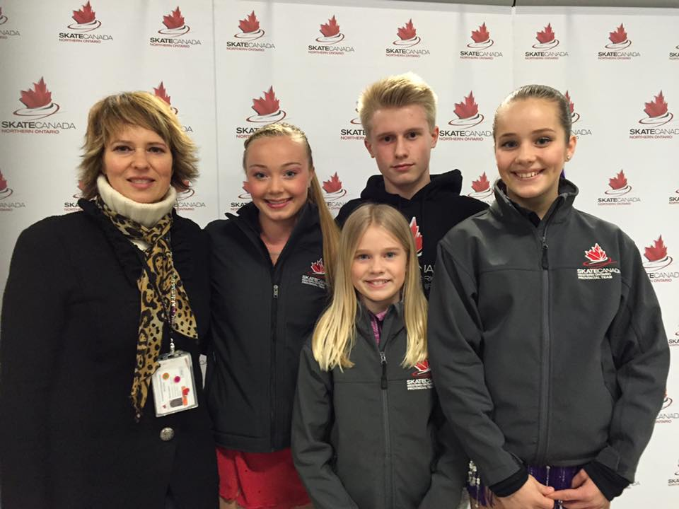 | 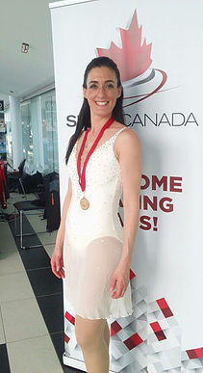
Pat Abela/Lyle McPhedran Memorial – January 23-26, 2016
Alexandra Klunder | Women's Bronze Triathlon | 3
Payton Marr | Senior Bronze Women | 1
Ava Stechey | STAR5 Girls over 13 | 1
Mackenzie Campbell | STAR5 Girls over 13 | 5
Nageen Ahmadi | STAR5 Girls under 13 | 4
Dennis Silverthorne Memorial Invitational – January 5-7, 2016
Alexandra Klunder | Women's Bronze Triathlon | 4
Kira Miller | Women's Bronze Triathlon | 5
Thomas Turner | Senior Silver Men | 2
Payton Marr | Senior Bronze Women | 4
Kalysta Fletcher | Senior Bronze Women | 5
Mackenzie Campbell | STAR5 Girls over 13 | 4
Ava Stechey | STAR5 Girls over 13 | 5
Nageen Ahmadi | STAR5 Girls under 13 | 2
Jodie Van Eck | STAR5 Girls under 13 | 6
Brooke Turner | STAR5 Girls under 13 | 9
Brett Newman | Silver Women’s Interpretive | 5
Jamie Lynn Belbeck | Silver Women’s Interpretive | 8
Kalysta Fletcher | Bronze Women’s Interpretive | 5
Western Ontario Section STARSkate Championships – February 26-February 28, 2016
Alexandra Klunder | Women's Bronze Triathlon | 3
Kira Miller | Women's Bronze Triathlon | 4
Thomas Turner | Senior Silver Men | 2
Kira Miller | Junior Silver Women | 10
Payton Marr | Pre-Juvenile Women under 13 | 2
Thomas &Brooke Turner | Juvenile Pairs | 1
Kalysta Fletcher | Women’s Senior Bronze | 9
Mackenzie Campbell | STAR5 Girls under 13 | 5
Ava Stechey | STAR5 Girls over 13 | 6
Nageen Ahmadi | STAR5 Girls under 13 | 4
Jodie Van Eck | STA5 Girls under 13 | 6
Lilly Vandaele | STAR5 Girls under 13 | 8
Brooke Turner | STAR5 Girls under 13 | 15
Abigail Beck | STAR4 Girls Under 13 | 5
Charlie Iverson | STAR4 Boys Under 13 | 3
Sasha Kenyon | Silver Women Interpretive | 4
Brandon Zwicker | Bronze Men Interpretive | 1
Brett Newman | Silver Women’s Interpretive | 8
Jamie Lynn Belbeck | Silver Women’s Interpretive | 8
Kalysta Fletcher | Bronze Women’s Interpretive | 8
ONTARIO STARSKATE CHAMPIONSHIPS – March 18-20, 2017
Alexandra Klunder | Women's Bronze Triathlon | 11
Thomas Turner | Senior Silver Men | 3
Payton Marr | Pre-Juvenile Women under 13 | 4
Thomas &Brooke Turner | Juvenile Pairs | 2
ADULT FIGURE SKATING CHAMIONSHIPS
Roselle Doyle | Elite Women’s Interpretive | 1

